**队伍：Room404**

**队长：金鑫**

**队员：梁思宇、周宇宸、李斐**

**概要功能设计表**

|  |  |
| --- | --- |
| 功能 | 对应逻辑包 |
| Commodity | Commodityui, Commoditybl, Commoditydata, Invoidcebl, Invoicedata, Systemlogbl, Systemlogdata |
| Sales | Salesui, Salebl, Saledata, Commoditybl, Commoditydata, Invoicebl, Invoicedata, Systemlogbl, Systemlogdata |
| Account | Accountui, Accountbl, Accountdata, Financialbl, Financialdata, Salesbl, Salesdata, Invoicebl, Invoicedata, Systemlogbl, Systemlogdata |
| Financial | Financialui, Financialbl, Financialdata, Accountbl, Accountdata, Systemlogbl, Systemlogdata, Commoditybl, Commoditydata, Salesbl, Salesdata |
| Initialization | Initializationui, Initializationbl, Initializationdata, Commoditybl, Commoditydata, Salesbl, Salesdata, Accountbl, Accountdata, Systemlogbl, Systemlogdata |
| Systemlog | Systemlogui, Systemlogbl, Systemlogdata |
| Invoice | Invoiceui, Invoicebl, Invoicedata, Commoditybl, Commoditydata, Salesbl, Salesdata, Accountbl, Accountdata, Systemlogbl, Systemlogdata |
| Promotion | Promotionui, Promotionbl, Promotiondata, Commoditybl, Commoditydata, Salesbl, Salesdata, Accountbl, Accountdata, Systemlogbl, Systemlogdata |
| User | Userui, Userbl, Userdata, Systemlogbl, Systemlogdata |

**初始开发包设计表**

|  |  |
| --- | --- |
| **功能** | **对应逻辑包** |
| mainui | Commodityui, Salesui, Accountui, Financialui, Initializaionui, Systemlogui, Invoiceui, Promotionui, Userui |
| Commodityui | Commodityblservice,界面类库包,vo |
| Commodityblservice |  |
| Commoditybl | Commodityblservice, Commoditydataservice, po, Invoicebl, Systemlogbl |
| Commoditydataservice | JavaRMI, po |
| Commoditydata | JavaRMI, po, databaseutility |
| Salesui | Salesblservice,界面类库包,vo |
| Salesblservice |  |
| Salesbl | Salesblservice, Salesdataservice, po, Commoditybl, Invoicebl, Systemlogbl |
| Salesdataservice | JavaRMI, po |
| Salesdata | JavaRMI, po, databaseutility |
| Accountui | Accountblservice,界面类库包,vo |
| Accountblservice |  |
| Accountbl | Accountblservice, Accountdataservice, po, Financialbl, Invoicebl, Systemlogbl, Salesbl |
| Accountdataservice | JavaRMI, po |
| Accountdata | JavaRMI, po, databaseutility |
| Financialui | Financialblservice,界面类库包,vo |
| Financialblservice |  |
| Financialbl | Financialblservice, Financialdataservice, po, Accountbl, Systemlogbl, Commoditybl, Salesbl, Salesbl |
| Financialdataservice | JavaRMI, po |
| Financialdata | JavaRMI, po, databaseutility |
| Initializationui | Initializationblservice,界面类库包,vo |
| Initializationblservice |  |
| Initializationbl | Initializationblservice, Initializationdataservice, po, Commoditybl, Accountbl, Systemlogbl, Salesbl |
| Initializationdataservice | JavaRMI, po |
| Initializationdata | JavaRMI, po, databaseutility |
| Systemlogui | Systemlogblservice,界面类库包,vo |
| Systemlogblservice |  |
| Systemlogbl | Systemlogblservice, Systemlogdataservice, po |
| Systemlogdataservice | JavaRMI, po |
| Systemlogdata | JavaRMI, po, databaseutility |
| Invoiceui | Invoiceblservice,界面类库包,vo |
| Invoiceblservice |  |
| Invoicebl | Invoiceblservice, Invoicedataservice, po, Commoditybl, Salesbl, Accountbl, Systemlogbl |
| Invoicedataservice | JavaRMI, po |
| Invoicedata | JavaRMI, po, databaseutility |
| Promotionui | Promotionblservice,界面类库包,vo |
| Promotionblservice |  |
| Promotionbl | Promotionblservice, Promotiondataservice, po, Commoditybl, Salesbl, Systemlogbl |
| Promotiondataservice | JavaRMI, po |
| Promotiondata | JavaRMI, po, databaseutility |
| Userui | Userblservice,界面类库包,vo |
| Userblservice |  |
| Userbl | Userblservice, Userdataservice, po, Systemlogbl |
| Userdataservice | JavaRMI, po |
| Userdata | JavaRMI, po, databaseutility |
| Vo |  |
| Po |  |
| Utilitybl |  |
| 界面类库包 |  |
| Java RMI |  |
| databaseutility | JDBC |

**体系结构风格**

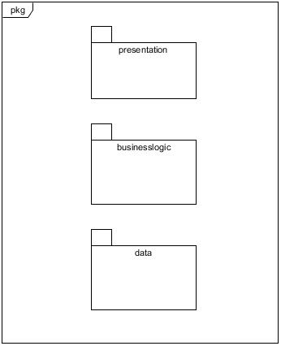

**体系结构逻辑图**

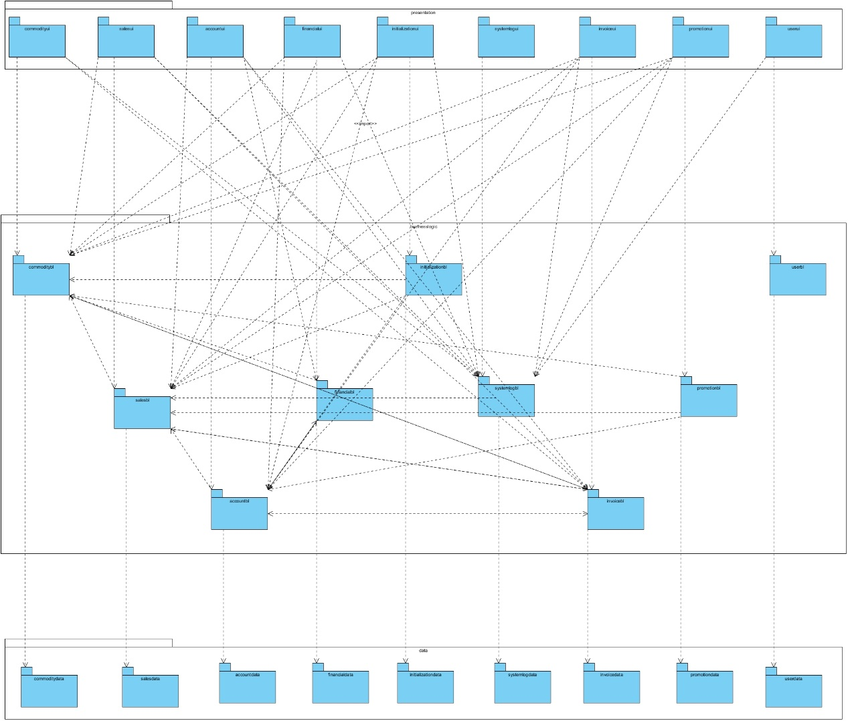

**系统开发包图**

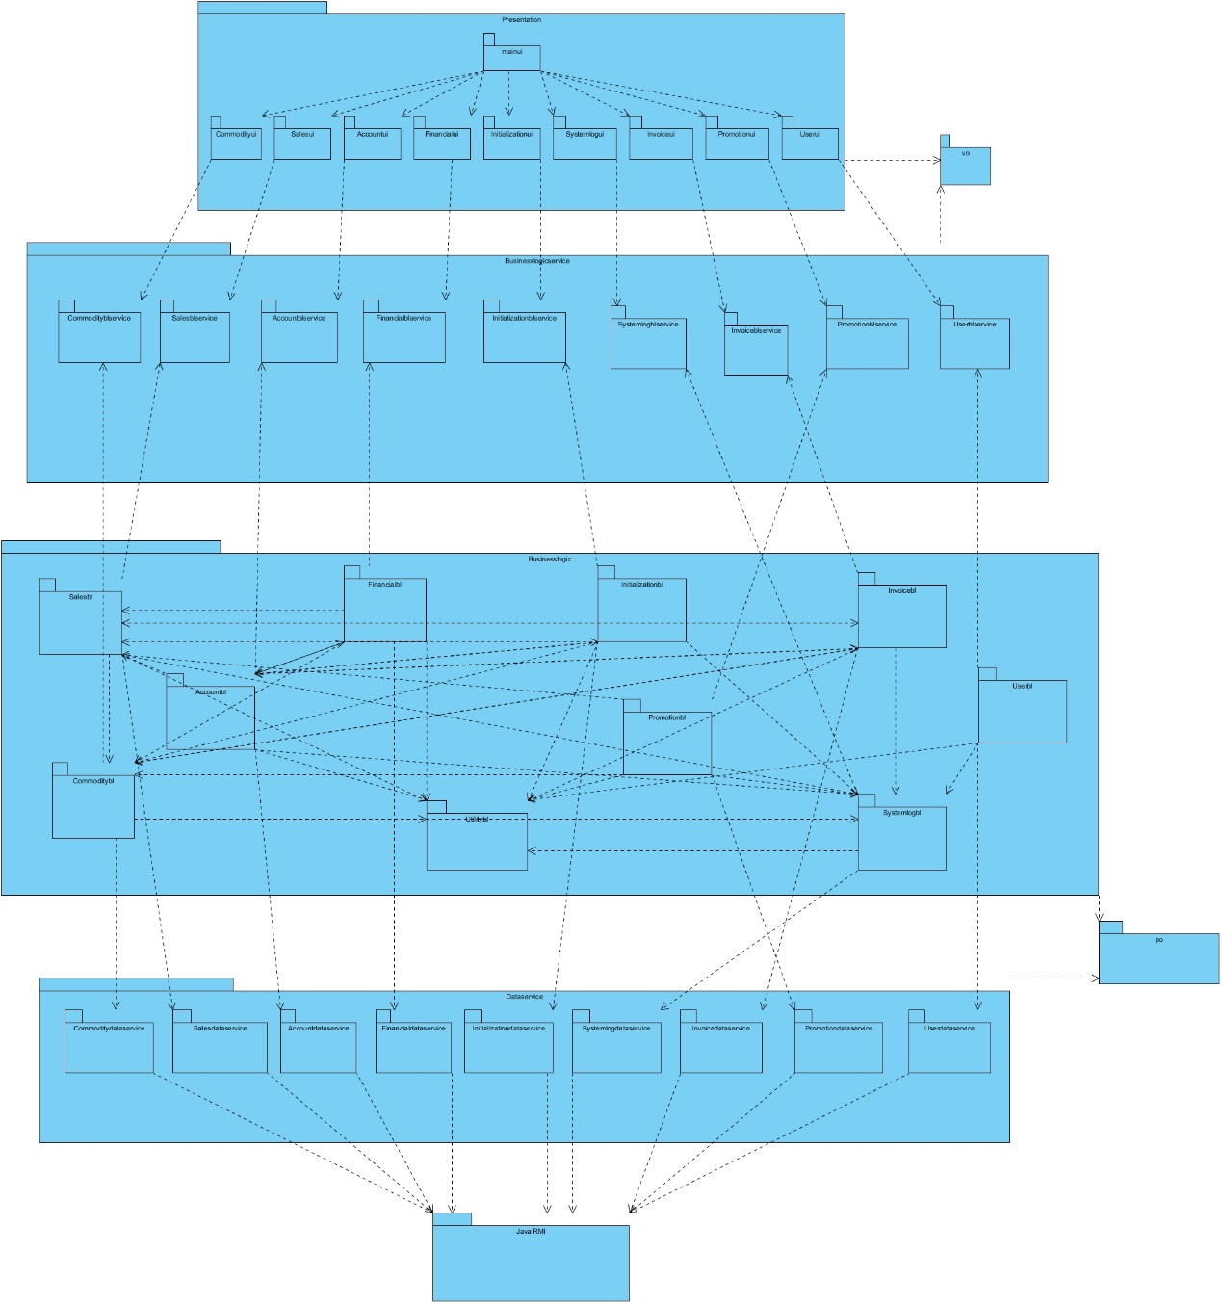

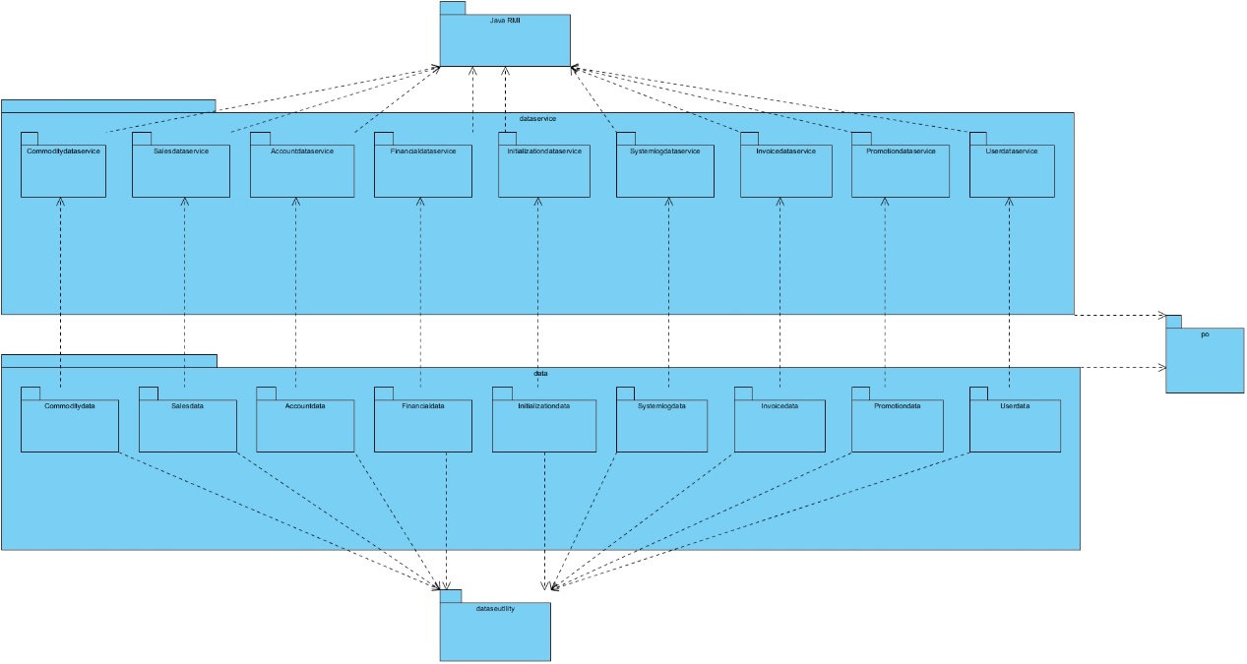

**进程图**

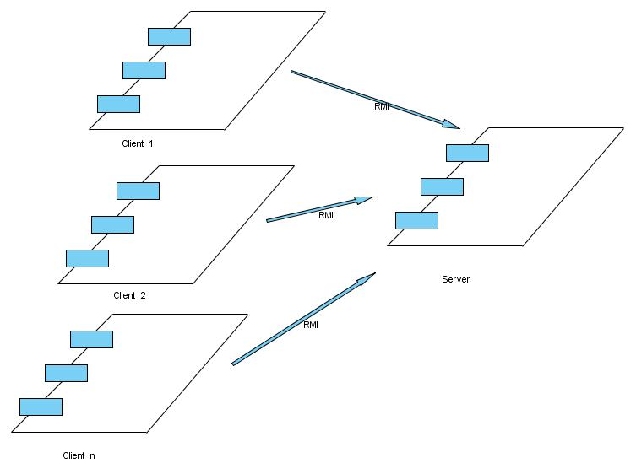

**部署图**

